
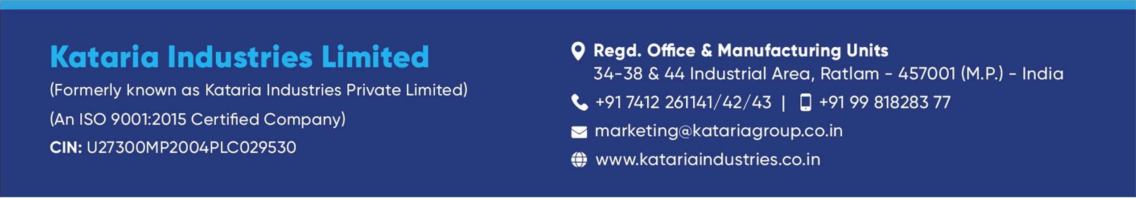


Statutory Auditor of the Company

Peer Review Auditor of the Company

Name | P.D Nagar & Co.
Registered Office | 403, City Plaza, 564, M G Road, A B Road, Indore -  452001
Tel No. | 079-47140878
Email | nagarpd@rediffmail.com
Membership No. | 008627
Firm Registration No. | FRN 001231C
Contact Person | CA P.D Nagar

Name | KARMA & CO LLP
Registered Office | 503, 5th Floor, Patron, Opp. Kensvilla Golf Academy, Rajpath to S. P. Ring Road,  Bodakdev, Ahmedabad- 380 054
Tel No. | 079-40394154
Email | hd.office@karmallp.in
Membership No. | 129149
Firm Registration No. | 127544W/W100376
Contact Person | CA Jignesh A Dhaduk

Cost Auditor of the Company

Name` | RITU & CO.
Registered Office | B-4, DIWAN COLONY, JAMANI ROAD, ITARSI, Madhya Pradesh-MP, 461111
Tel No.
Email | cma.ritudubey@gmail.com
Membership No. | 38057
Firm Registration No. | 001805
Contact Person | CMA RITU DUBEY

Secretarial Auditor of the Company

Name` | M/s. ALAP & Co. LLP
Registered Office | 416, 4th Floor, Shreenathji Staff Co.Op.Soc.Ltd,  Pushpam Complex, Opp. Seema Hall, Satellite,  Ahmadabad, Gujarat, 380015
Tel No. | 079-40051702
Email | csanandlavingia@gmail.com
Membership No. | F8536
Firm Registration No. | L2023GJ013900
Contact Person | Ankita Patel

